2. ReactJS-HOL

**Solution:**

**1:** Created a React project named “**StudentApp**” type the following command in terminal of Visual by studio by the following command:  
 **npx create-react-app studentapp**

Note: The name of above react project doesn’t accept capital letters hence I named it “studentapp”   
 instead of “StudentApp”.   
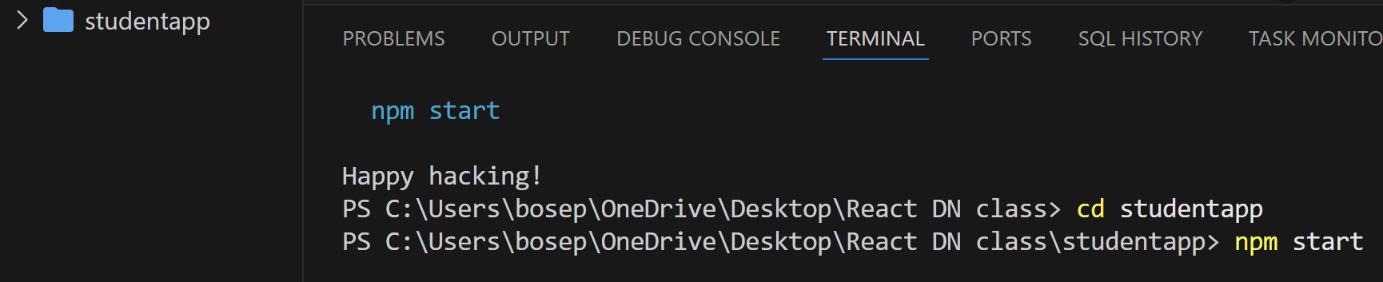

**2**. **Created a new folder** under Src folder with the name “**Components**”. **Added a new file** named “**Home.js**”

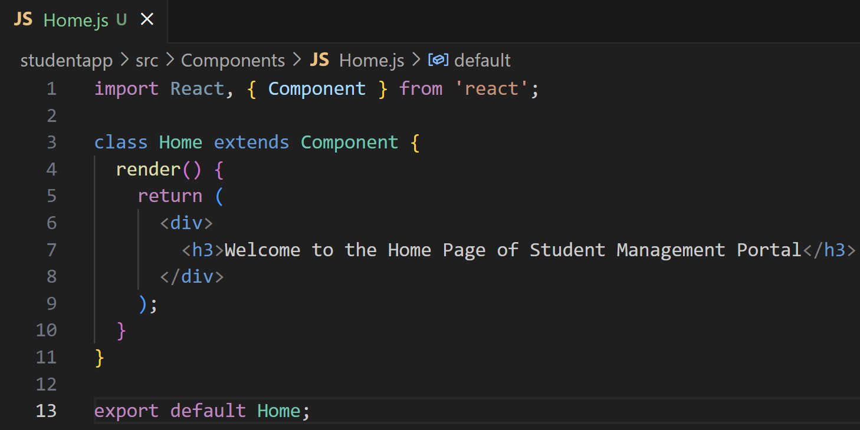

**3**. Under Src folder **added another file** named “**About.js**”

**4**. Repeated the same steps for Creating “About” and “Contact” component by adding a new file as  
”**About.js**”, “**Contact.js**” under “Src” folder and edit the code as mentioned for “Home” Component.

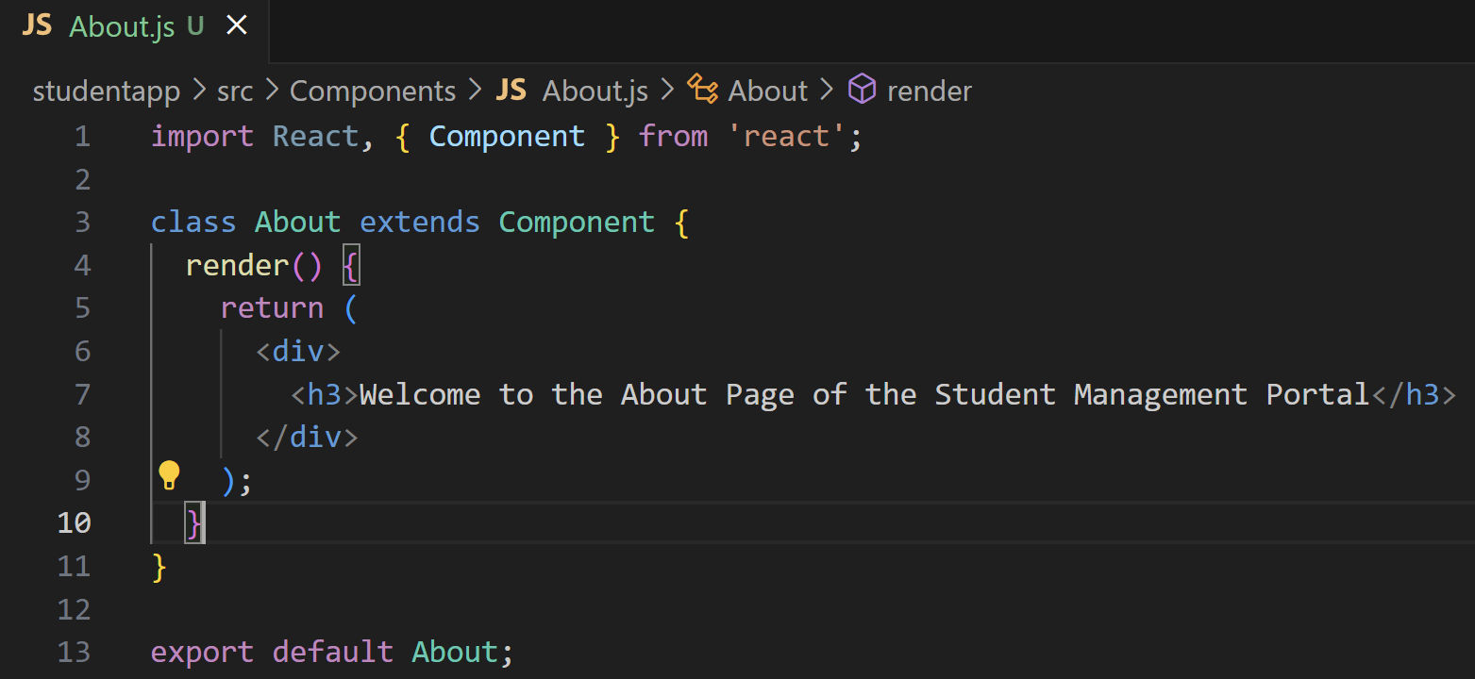

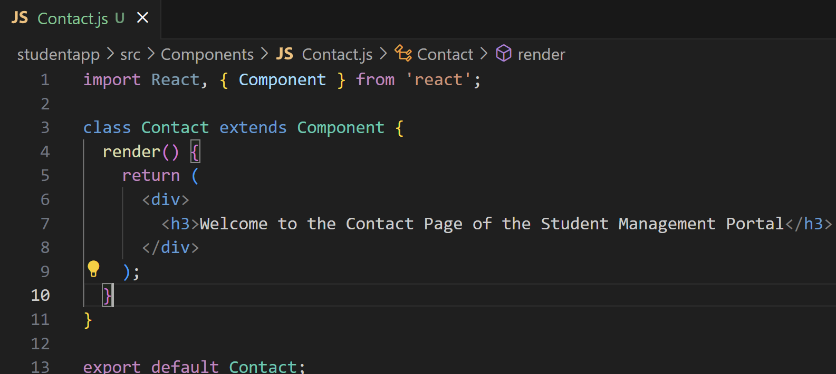

**5. Edited the App.js** to invoke the Home, About and Contact component as follows:

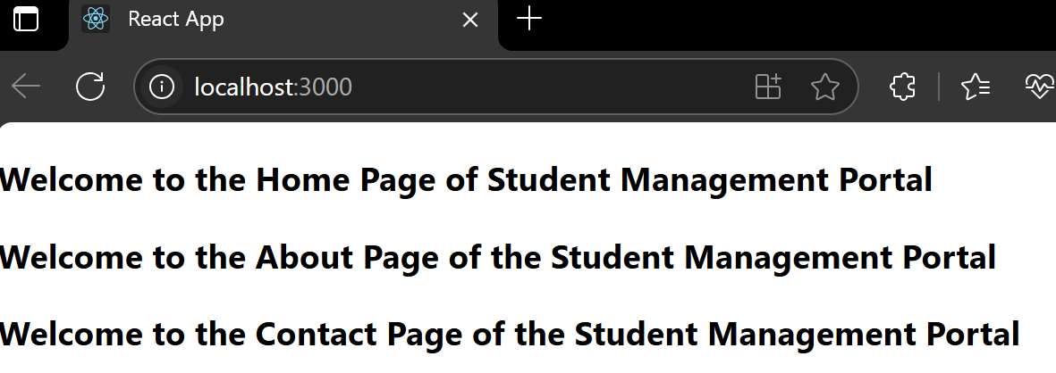**6**. **Open browser** and type “**localhost:3000**” in the address bar:

